

#### 16x28mm Coreless Brushed Series

**SPECIFICATIONS:**

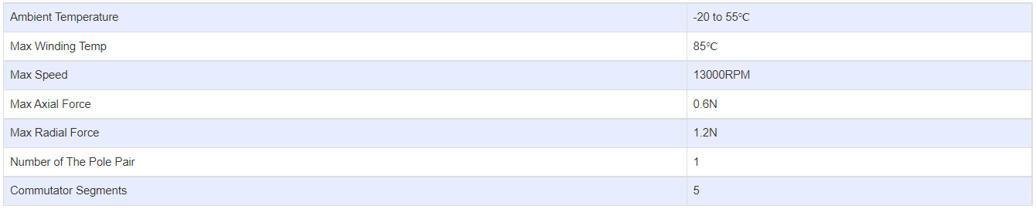

**SUBMODELS:**

*The following are common submodels for the LDO-CL1628 series.*

